## Creating and Managing Site Collections

**Lab Time**: 45 minutes

**Lab Folder**: C:\Student\Labs\07.SiteCollections

**Lab Overview**: In this lab you will create and modify a number of site collections.

### Exercise 1: Creating a Site Collection with SharePoint Central Administration

In this exercise you will create a new SharePoint site collection using the SharePoint Central Administration site.

1. In the **WingtipServer** VM open SharePoint Central Administration from **Start** » **All Programs** » **Microsoft SharePoint 2010 Products** » **Microsoft SharePoint Central Administration**.
2. Click on the Application Management link in the Quick Launch to navigate to the Application Management page.
3. Inside the Site Collections section of this page, you should see several links for creating and managing site collections.
4. Click in the link titled View all site collections which takes you to a page which shows you the site collections in a given Web Application. By clicking on the individual site collections on the left, you should be able to view information about each site collection on the right of the page.
5. If it isn’t already set, switch the selected Web Application (using the control in the upper-right corner of the page) to http://intranet.wingtip.com.
6. Now it is time to create a new site collection. Click on the Application Management link in the Quick Launch bar and then click on the link in the Site Collections section titled Create site collections. Once you have done this you should be at a page that allows you to enter information for creating a new site collection. Enter the following information so that your screen looks like the screenshot shown below and then click OK to begin the provisioning process to create a new site collection.

**Web Application**: intranet.wingtip.com

**Title**: Wingtip Sales Site

**Description**: Workplace for overly aggressive sales personnel

**Url**: http://intranet.wingtip.com/sites/Sales

**Template**: Team site (*this template is in the Collaboration tab*)

**Primary Site Collection Administrator User Name**: WINGTIP\administrator

**Secondary Site Collection Administrator User Name**: (leave blank)

**Quota Template**: No Quota

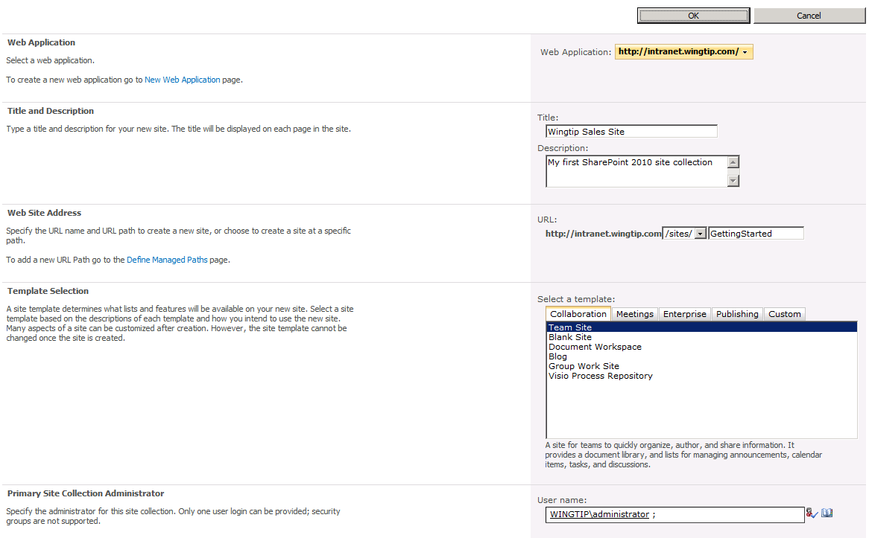

1. After the site collection provisioning process is complete, you should see a page as the one shown below. Click on the provided link to navigate to new site.

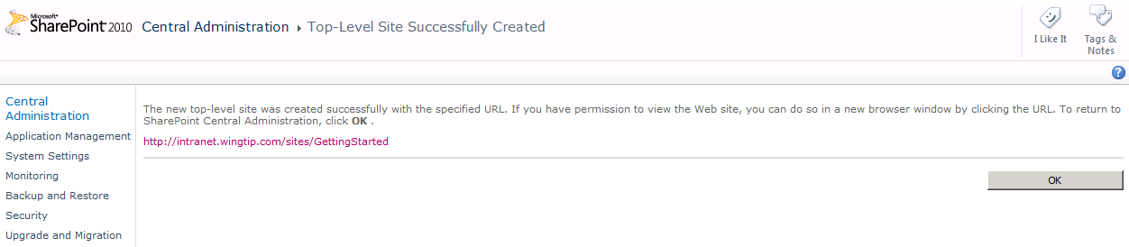

1. When you see the newly-provisioned site collection with a Team site as its top-level site, move on to the next exercise.

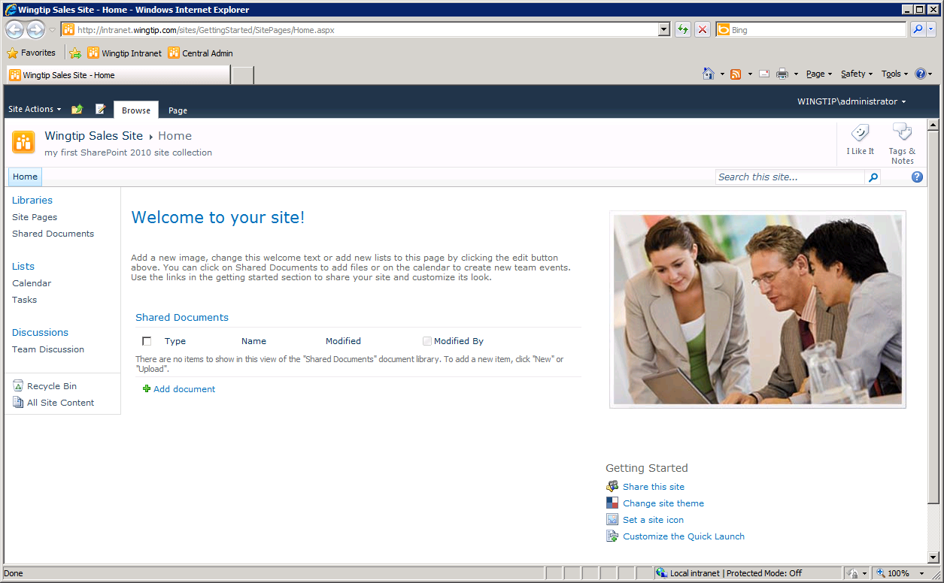

In this exercise you learned how to create a SharePoint site collection using the SharePoint Central Administration.

### Exercise 2: Creating new Sites using PowerShell

In this exercise you will use PowerShell to create new sites based on different site templates.

1. Open **Windows Explorer** and locate the files in [[LAB FILES]]\Starter Files.
2. Open the CreateBlankSiteAtRoot.bat file and verify the instructions inside: this command file only executes a PowerShell script with the same name located in the same directory. Close the file again.
3. Open the CreateBlankSiteAtRoot.ps1 file and verify the statements inside:
   1. The first part defines a number of variables like the title for the new site, the URL where the new site will be created and the site template that will be used, in this case the blank site template.

$SiteTitle = "Wingtip Blank Site"

$SiteUrl = "http://intranet.wingtip.com"

$SiteTemplate = "STS#1"

* 1. The second part of the script loads the Microsoft.SharePoint.PowerShell snap-in

$snapin = Get-PSSnapin | Where-Object {$_.Name -eq 'Microsoft.SharePoint.Powershell'}

if ($snapin -eq $null) {

Write-Host "Loading SharePoint Powershell Snapin"

Add-PSSnapin "Microsoft.SharePoint.Powershell"

}

* 1. The third part of the script check if there is already a site located at the specified URL. If so, this site is deleted.

$targetUrl = Get-SPSite | Where-Object {$_.Url -eq $SiteUrl}

if ($targetUrl -ne $null) {

Write-Host "Deleting existing site at" $SiteUrl

Remove-SPSite -Identity $SiteUrl -Confirm:$false

}

* 1. Then the new site is created using the values specified within the 3 variables.

Write-Host "Creating new site at" $SiteUrl

$NewSite = New-SPSite -URL $SiteUrl -OwnerAlias wingtip\Administrator -Template $SiteTemplate -Name $SiteTitle

$RootWeb = $NewSite.RootWeb

* 1. The last part of the script only displays some site information after creation.

Write-Host "-------------------------------------"

Write-Host "Site created successfully"

Write-Host "Title:" $RootWeb.Title -foregroundcolor Green

Write-Host "URL:" $RootWeb.Url -foregroundcolor Red

Write-Host "ID:" $RootWeb.Id.ToString() -foregroundcolor Blue

Write-Host "-------------------------------------"

1. Double-click theCreateBlankSiteAtRoot.bat file to create the new site.
2. Open Internet Explorer and navigate to the new SharePoint site: http://intranet.wingtip.com.
3. Return to Windows Explorer and open the CreateTeamSiteAtRoot.ps1 file to inspect the statements inside. The only difference is the value of the SiteTemplate variable: it specifies that the Team site template will be used to create the new site.

$SiteTemplate = "STS#0"

1. Double-click theCreateTeamSiteAtRoot.bat file to create the new site.
2. Open Internet Explorer and navigate to the new SharePoint site: http://intranet.wingtip.com.
3. Return to Windows Explorer and open the CreatePublishingSiteAtRoot.ps1 file to inspect its content. This PowerShell script differs from the previous scripts in that it uses additional arguments to create a publishing site.
4. The template name used is that of a publishing site and there are extra variables defined for the language in which the site must be created, and for the site owner:

$SiteTitle = "Wingtip Publishing Site"

$SiteUrl = "http://intranet.wingtip.com"

$SiteTemplate = "BLANKINTERNET#2"

$Locale = "1033"

$Siteowner = “wingtip\tedp”

* 1. The publishing site is created using the following instruction:

$NewSite = new-SPSite -url $SiteUrl -OwnerAlias $Siteowner -Language $Locale -Template $SiteTemplate -Name $SiteTitle

1. Double-click theCreatePublishingSiteAtRoot.bat file to create the new site.
2. Open Internet Explorer and navigate http://intranet.wingtip.com. You will get an access denied error because the account of Ted Pattison has been used as site Administrator.

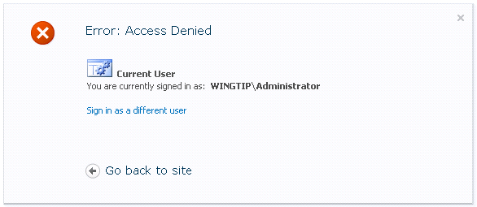

1. Click the **Sign in as different user** hyperlink and log on as WINGTIP\tedp.
2. Notice the differences with the previously created sites.

In this exercise you learned how to create a SharePoint sites using PowerShell.

### Exercise 3: Creating a Site Collection on a New Content Database

In Exercise 1 you created a new site collection using the SharePoint 2010 Central Administration. There was no option in there to create this site collection on a different content database. If you want to control in which content database site collections are created, you have to use PowerShell. In this exercise, you will learn how you can create a new site collection on a different content database using PowerShell.

1. Open the **SharePoint 2010 Management Shell**.
2. Type the following statement to get some help on creating new site collections using the New-SPSite cmdlet.

Get-Help New-SPSite

1. First you have to define a number of variables like the name of the web application to which you want to attach a new content database, the URL to that web application, the administrator account, etc.

$webapp = "wingtip"

$webappurl = "http://intranet.wingtip.com"

$siteurl = "http://intranet.wingtip.com/sites/wiki"

$template = "WIKI#0"

$owneralias = "wingtip\Administrator"

1. Then you have to create the new content database and attach it to the existing web application

New-SPContentDatabase $($webapp + "_Wiki") -WebApplication $webappurl

1. Then you can create the new site collection, based on for example the wiki template, into the new site collection.

New-SPSite -url $siteurl -OwnerAlias $OwnerAlias -Name "Wingtip Wiki" -Template $template -ContentDatabase $($webapp + "_Wiki")

1. Open **SQL Server Management Studio** and verify that the new content database has been created.
2. Click **Start** » **All Programs** » **Microsoft SQL Server 2008 R2** » **SQL Server Management Studio**. Note: SQL Server Management Studio may take a few moments to load for the first time.
   1. Select **Database Engine** for server type and **(local)** for the server name. Leave the Authentication drop-down to **Windows Authentication**. Click **Connect** to log in.
   2. Expand the Object Explorer tree through **(local)** » **Databases**. Verify the database named **wingtip_Wiki** is listed as seen in the screenshot below.

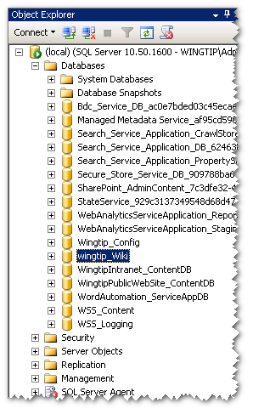

1. Open **SharePoint 2010 Central Administration**.
2. Navigate to **Application Management** and then choose **Manage content databases** to check if the new content database is attached to the http://intranet.wingtip.com web application.
3. Navigate back to **Application Management** and then choose **View all site collections** to verify that the new site collection has been created.
4. Open Internet Explorer and verify that the new site collection opens at http://intranet.wingtip.com/sites/wiki for the Administrator account.
5. Everything should be created successfully.

In this exercise you learned how to create a new content database, attach it to a web application and create a new site collection using PowerShell.

### Exercise 4: Working with the SharePoint 2010 Ribbon and In-place Editing

In this exercise, you will complete work inside the top-level site of the site collection you created in the previous exercise at http://intranet.wingtip.com/sites/Sales. You will begin by adding and viewing items inside of some of the lists that are automatically created as part of a new Team Site so you can experience the new paradigm for in-place editing. After that, you will work with a Web Part Page so you can experience how the SharePoint 2010 user interface has changed the way users manage Web Parts.

1. At this point you should be at the home page of the site created in the previous exercise at the URL http://intranet.wingtip.com/sites/Sales/SitePages/Home.aspx. Note that the home page is not default.aspx but rather a wiki page named Home.aspx located inside a wiki page library named SitePages.
2. Observe that the page Home.aspx already contains some generic content including large text block at the top of the page which reads "Welcome". Go into edit mode for the wiki page using the ribbon: Site Actions » Edit Page.

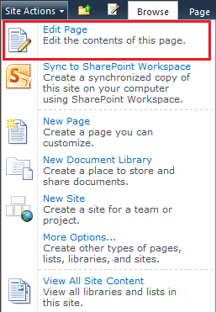

Alternatively, you could use the small edit button just before the **Browse** tab.

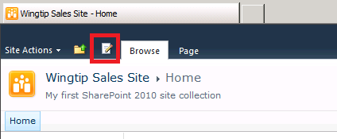

1. Once in edit mode, change the entire section of text that begins with "Welcome…" to "Wingtip Sales Site". Use the text formatting buttons in the ribbon to give your new text a font with a size and a color to your liking.
2. While still in edit mode, delete the graphic of the generic stock photo that has been placed on the right-hand side of the page. Now it’s time to add a different photo. Place you cursor on the page at the position where the old photo used to be. Using the ribbon, select the **Edit Tools »** Insert.

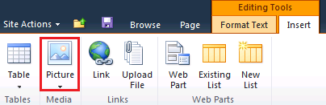

1. Click on the Picture button in the **Insert** tab in the ribbon to add a new picture to the page which should bring up the Select Picture dialog shown below.

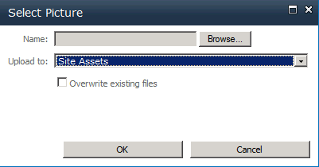

1. Note that the Add Picture dialog will allow to select a graphic image which will be automatically uploaded and stored in a special document library named Site Assets. Click the Browse button of the **Add Picture** dialog and navigate to and select the image at the following location:

[[Lab Files]]\Starter Files\JayHenningsen.jpg

1. Click the Save button in the next dialog.
2. Place the cursor after the picture and press [ENTER].
3. Add the following text right below the picture: **Jay Henningsen – Director of Sales**
4. Now that you have made some cosmetic changes to the home page, save your changes using the ribbon by selecting **Editing Tools » Format Text » Save & Close**. Alternatively, you could use the small Save button next to the Browse tab.

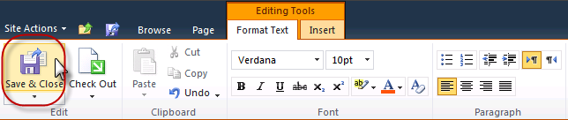

1. Your changes should look as follows:

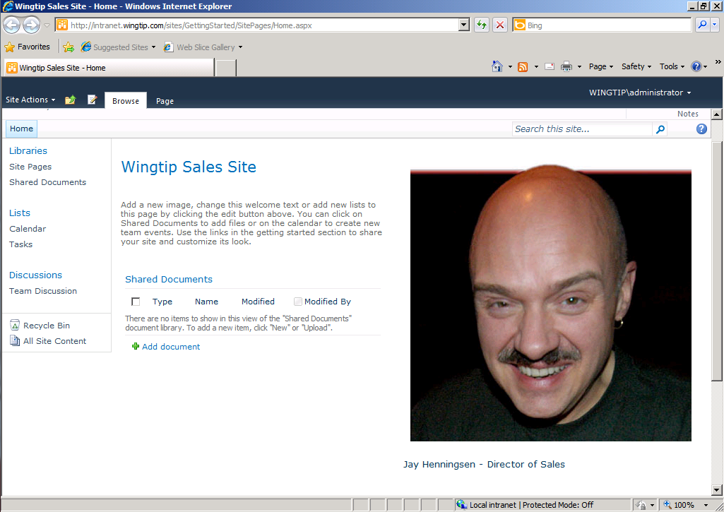

1. Now it's time to explore some other parts of the new site. Drop down the Site Actions menu and see what menu items are available. Click on the menu item titled Site Settings to navigate to Site Settings page. Inspect all the various links to the various administration pages that have been designed for site collections owners and site administrators.
2. Click on the link on the Site Settings page in the Look and Feel section titled Title, description and icon. This hyperlink takes you to a page where you can see the title and description you entered for the site in the previous exercise. Enter a new value for the Logo URL to assign the site a different site icon. You can use one of the following URLs which point to images that are part of the standard installation for SharePoint 2010.

/_layouts/images/search.png

/_layouts/images/unknownperson.png

/_layouts/images/gears_an.gif

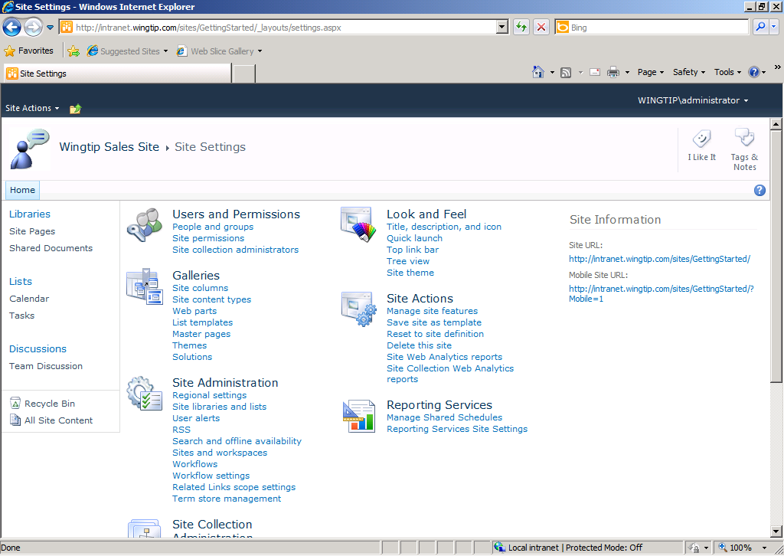

1. Now it is time to add a new item to a list so you can experience working with the new server-side ribbon and in-place editing. Click on the Tasks link in the Lists section of the Quick Launch bar to navigate to the Tasks list which was created as part of every new Team site. You should observe that there are no existing task items in this list. You should also observe the Task list has an associated server-side ribbon with a set of tabs including Browse, Items and List. Click on each of these tabs to see how the ribbon changes to display a contextual set of controls for a given set of tasks.
2. Click on the Items tab of the Task list and then drop down the New Item menu and select Task. This action will display an input form for you to enter the data for a new task item and to click OK to save the new task item back to the content database. The next step will provide you with the data for the new task. At this point it is important for you to observe that the new SharePoint 2010 user interface experience is allowing you to add and edit task items without making the user endure HTTP post backs as was required in the previous version of SharePoint.

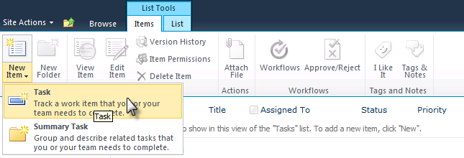

1. Create a new task using the following data.

**Title**: Learn how to install and configure SharePoint 2010

**Predecessors**: none

**Priority**: (1) High

**Status:** In Progress

**Complete**: 2%

**Assigned To**: Wingtip\Administrator

**Description**: Find out how to install and configure SharePoint 2010

**Start Date**: 11/5/2010

**Due Date**: 10/6/2010

1. Create a second new task using the following data.

**Title**: Configure service applications in SharePoint 2010

**Predecessors**: Learn how to install and configure SharePoint 2010

**Priority**: (1) High

**Status**: Not Started

**Complete**: 0%

**Assigned To**: Wingtip\Administrator

**Description**: Configure additional service applications in SharePoint 2010

**Start Date**: 11/6/2010

**Due Date**: leave blank

1. Once you have entered the two tasks from the previous steps, experiment with the list view if items in the task list by hovering over individual items. Note that each item highlights as you hover over it and the UI gives you the ability to select it. Use the Edit Control Block (ECB) menu (the standard SharePoint item-hover menu) to go into edit mode for one of the tasks you have created as shown below. Make a simple edit to the task and save it to observe the in-place editing behavior.

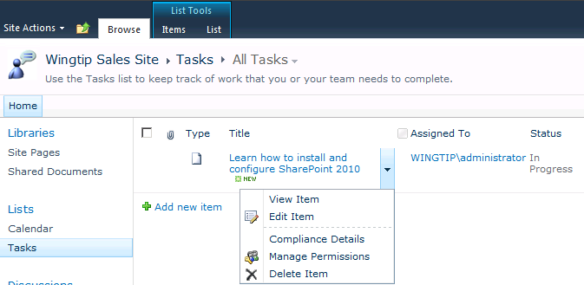

1. Now it is time to add a Web Part to a Web Part Page using the new UI experience for managing Web Parts. Navigate to the home page of the site by first clicking the **Browse** tab to show the top navigation (*the horizontal navigation that starts with “Home”*) bar and then by clicking on the **Home** button on the top navigation bar.

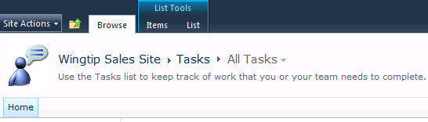

Alternatively, you could use the Navigate Up (*the folder icon next to the Browse tab*) button.

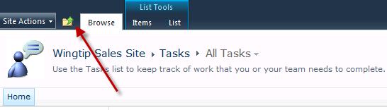

A treeview appears containing the site hierarchy. Select Wingtip Sales Site from the treeview.

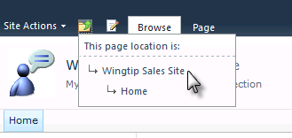

1. Note that the ribbon on the home page has two tabs titled Browse and Page. Click on the Page tab and then click the **Edit** button. Once you place the page in edit mode you should see a new contextual tab with the caption of Editing Tools. Now click on each of these tabs and see how the contextual controls on the ribbon change for each of these tabs.

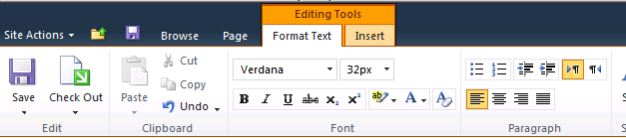

1. Click on the Insert tab that takes you into the mode for adding, modifying and deleting Web Parts from the page.
2. Delete the Shared Documents Web Part in the Left Web Part Zone by clicking on the Delete command inside the Web Part menu.

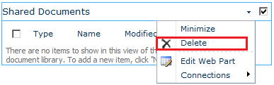

1. Now add a new Web Part to display the tasks inside the Tasks list. Place your cursor below the welcome message and using the ribbon select **Editing Tools » Insert » Web Part** button which is shown in the following screenshot:

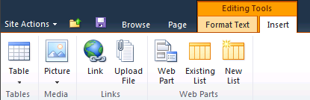

1. At this point you should see the new SharePoint 2010 UI for adding new Web Parts to a page. Select Lists and Libraries in the left-hand section and then select Tasks in the right-hand section. Once you have selected the Tasks list, you can observe that the drop-down box on the far right bottom (shown below) has the **Rich Content** zone selected. Click the Add button to add the Web Part instance to the page.

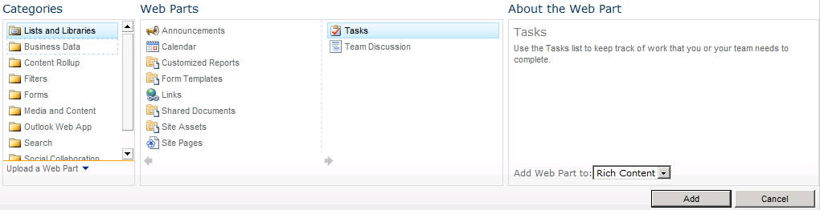

1. Save your changes by selecting the Save icon () on the ribbon. Alternatively, you can click on the **Format Text** tab and click the **Save & Close** button. Now that you have completed this exercise, you should have a page that looks like the one shown below.

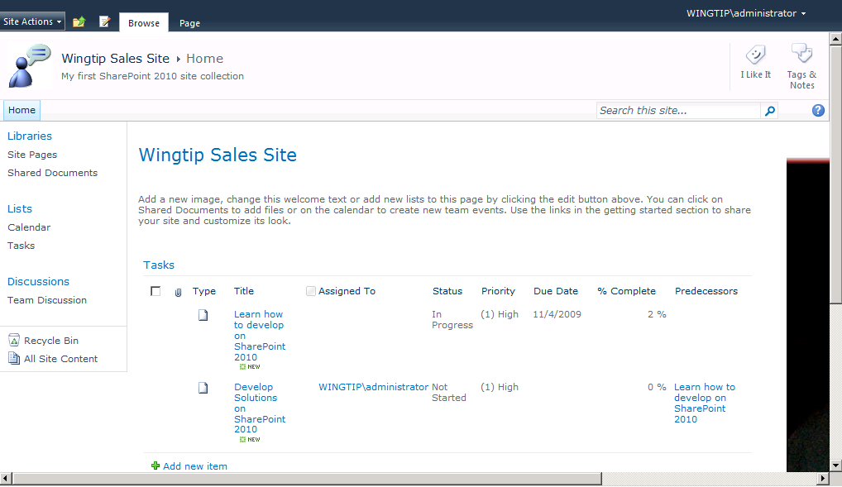

In this exercise you got some hands-on experience in working with improvements to the SharePoint user interface such as the new ribbon and adding Web Parts to a page.

### Exercise 5: Administering Sites and Site Collections

In this exercise, you will see that there are different administration tasks that need to be fulfilled both at the site collection level and at the site level.

1. Navigate to the URL http://intranet.wingtip.com/sites/Sales/SitePages/Home.aspx.
2. Choose the **Site Actions** button and look at the different options that are there.
3. Using the **New Document Library** you can create a new document library
   1. Using **New Site** you can create a new sub site
   2. Using **More Options** you can create any type of list, library, site or workspace
   3. Using Site **Permissions** you can define the permissions for the current site

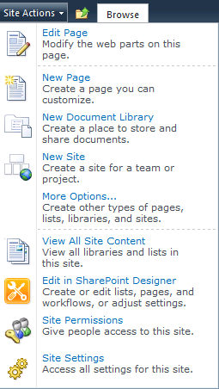

1. Choose **Site Settings**, which brings you to the **Site Settings** page. As you can see there are different categories of site settings that can be managed.

If this is a root site, you have an additional section **Site Collection Administration**, like in this case, where you can manage settings that are applicable through the whole site collection.

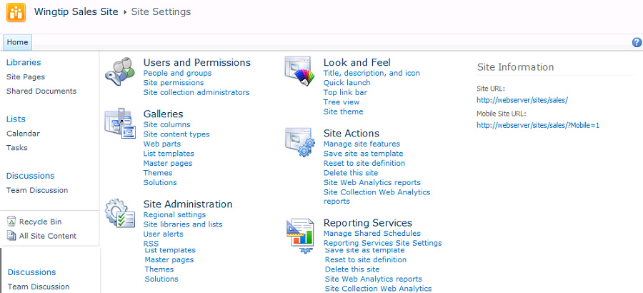

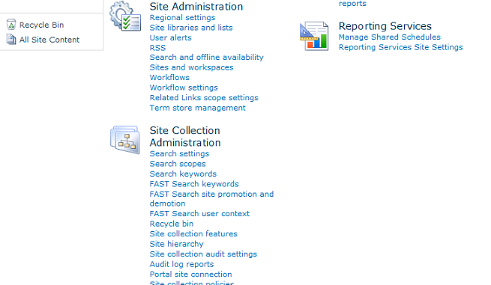

1. Click the **Site collection features** hyperlink under the **Site Collection Administration** section. In this page you can activate and/or deactivate features that are applicable at site collection level. You could, for example, activate the **Search Server Web parts** feature if you intend to create a search center sub site.
2. Return to the **Site Settings** page and click the **Manage site features** hyperlink under the **Site Actions** section. Here you find all features that are applicable at site level.
3. Return to the **Site Settings** page and click the **Workflow settings** hyperlink under the **Site Administration** section.

This brings you to a page where you can manage site workflows. Click the **Add a workflow** link and choose the **Schedule Web Analytics Reports** workflow. Give it the name **Wingtip Sales Analytics Reports**.

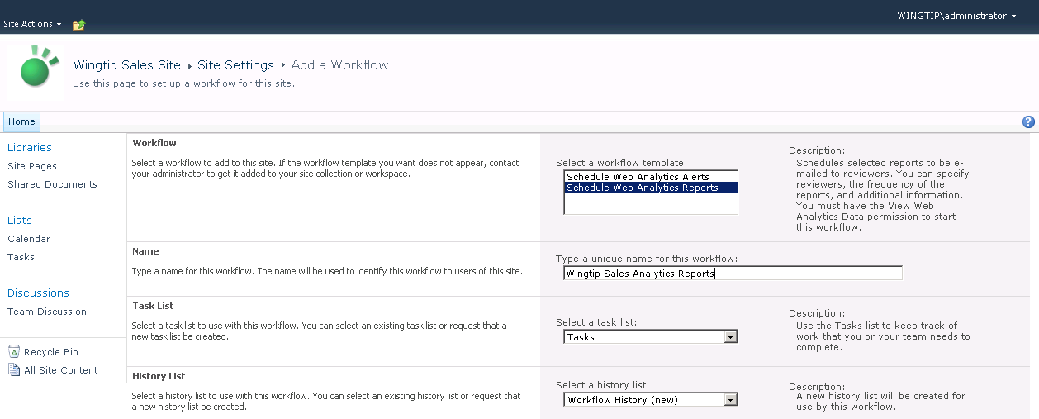

1. Leave all other settings unchanged and click the **Next** button.
2. This brings you to a page specific to the Analytics Reports workflow. Here you can fill out who must receive the reports. Fill out the WINGTIP\Administrator account.
3. Specify a message like for example “**Here are the weekly reports again!**”
4. You can also specify the frequency of the reports, which can be daily, weekly or monthly. Choose to send the reports **weekly**.
5. You can also indicate a start and an end date, but leave the defaults.
6. In the **Site Scope** section you can specify if the reports must be produced for the whole site collection or for this site only. Choose **This Site Collection**.

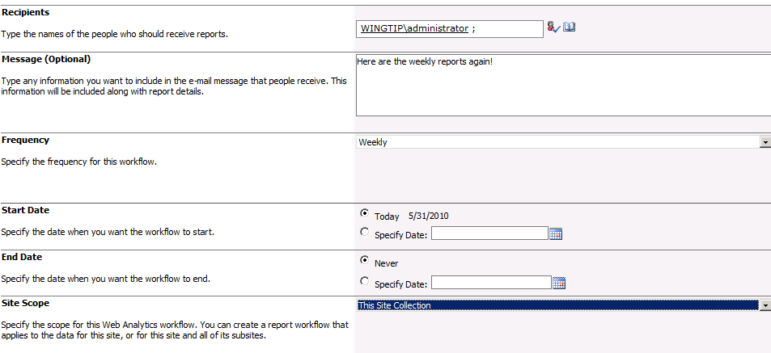

1. The last section is about the type of Web Analytics Reports that should be generated. Select them all.

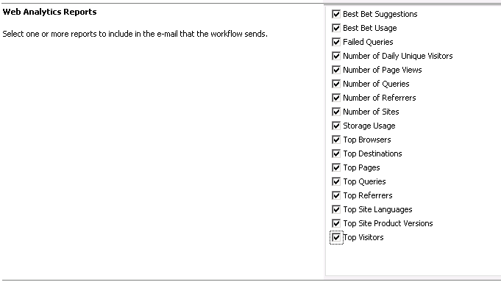

1. Click the **Finish** button at the bottom of the page to start the workflow. The wingtip administrator will now receive the Web Analytics reports on a weekly base.

This exercise walked you through the different administration tasks that are available on site collection level and on site level.

### Exercise 6: Manage Site Collection Storage and Locks

A quota template consists of the storage limit that specifies how much data can be stored in a site collection. When you save quota configurations as quota templates, you can simplify setting storage limits on new site collections. A quota template also defines when site collection administrators receive storage limit notifications.

When you apply a quota template to a new site collection, the storage limit that you specify for that site collection applies to the top-level site and the sub sites within that site collection. If versioning is enabled, versions in a site and content in the Recycle Bins count toward storage limits. You can also specify a percentage of storage limits for the second-stage Recycle Bin

1. In a first step you are going to create a new quota template.
2. Open **SharePoint 2010 Central Administration**.
   1. Click **Application Management**.
   2. Under the **Site Collection** section click the **Specify quota templates** hyperlink.

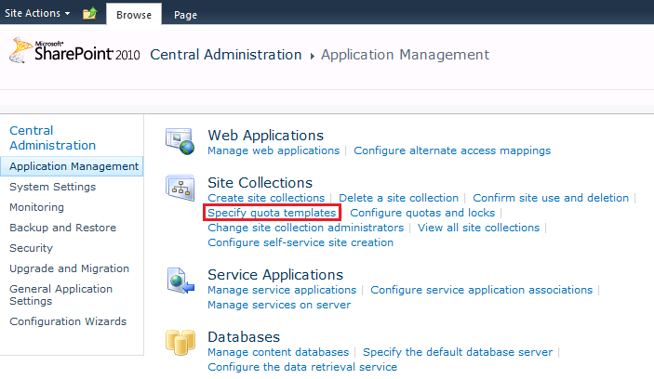

* 1. On the **Quota Templates** page you can specify the following:
     1. In the **Template Name** section, specify a new name like **Demo storage**.
     2. In the Storage Limit Values section
        1. Check the **Limit site storage to a maximum** **of** check box and specify a value (e.g. **100 MB**).
        2. Check the **Send a warning E-mail when Site Collection storage reaches** check box and specify a value (e.g. **80 MB**). E-mail messages are sent daily until the storage level drops below the warning level. When a site collection meets the maximum limit, another e-mail message is sent to the owner and administrator, and no new content can be added to the site collection.
     3. You can also specify limits for sandboxed solutions.

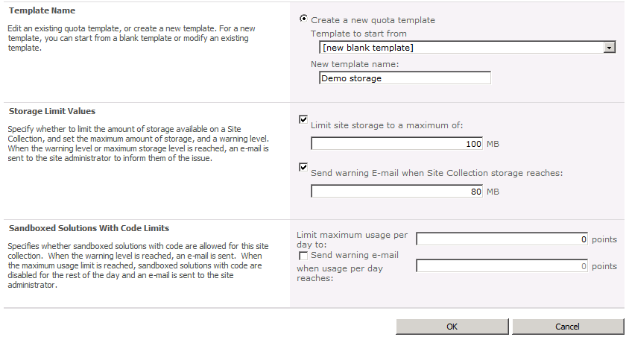

* 1. Click the **OK** button to store your quota template.
  2. You can now create a new site collection for the Marketing department using this quota template.

1. In SharePoint Central Administration click **Application Management**.
2. Under the Site Collections section, click the **Create site collections** hyperlink.
3. Verify the Web Application is http://intranet.wingtip.com and enter **Marketing** as title and as the URL for the site collection.
4. Choose **Document Workspace** as site collection template, but it can be any type of template.
5. Define the **WINGTIP\Administrator** as the primary administrator.
6. In the Quota Template section select your newly created quota template.

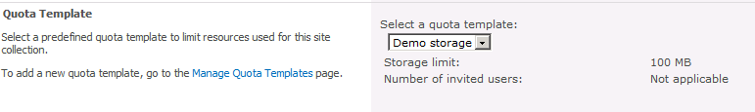

1. Click the **OK** button to create the site collection. You site collection is now limited in size to 100 MB.
2. Changing the quota template values does not change the values for any existing site collections that are based on that template. To change the storage limits for the site collection, you must do so manually.
3. In **SharePoint 2010 Central Administration** click **Application Management**.
   1. Under the **Site Collection** section, click the **Configure quotas and locks** hyperlink.
   2. In the **Site collection** section, select the marketing site collection you just created.
   3. In the **Site Lock Information** section you could specify the type of lock for a site. This can be useful if the site collection is in violation with your site use policies. Depending on the type of lock, the result of a locked site collection is different. Leave these settings as is.

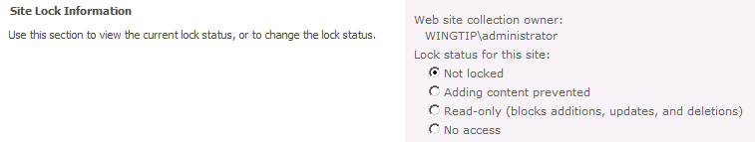

* 1. In the **Site Quota Information** section you can see that the site collection was created based on a quota template. The ability to change the limits is disabled.
  2. You can choose **Individual Quota** from the dropdown list to be able to modify the limits. Set the storage limit to a maximum of **120 MB** and the warning limit to **100 MB**.

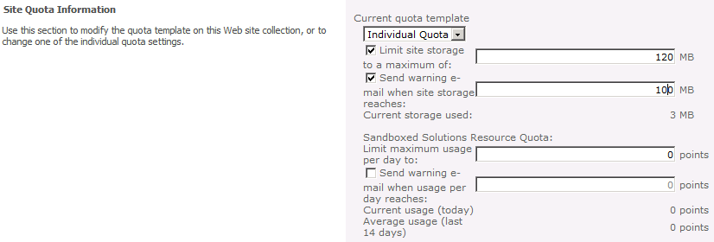

* 1. Click the **OK** button to save your changes.

In this exercise you learned how to limit storage of site collections. Remember that modifications to a storage template only apply to new site collections.

### Exercise 7: Manage Large Lists and List Throttling

SharePoint 2010 introduces a new feature called large list throttling.

The throttling definition from the Microsoft SharePoint Evaluation Guide is as follows: “*Through throttling settings, SharePoint Server 2010 provides a way for administrators to determine the level at which the server will go into throttling mode. Every five seconds, a job runs that checks server resources compared to configured levels. By default, Server CPU, Memory, Request in Queue, and Request Wait Time are monitored. After three unsuccessful checks, the server enters a throttling period and will remain in this state until a successful check is completed. Requests that were generated prior to the server’s entering throttling mode will be completed. This will, in theory, keep users from losing any current work when the server begins to throttle requests. Any new HTTP GET and Search Robot requests will generate a 503 error message and will be logged in the event viewer. While the server is in a throttling period, no new timer jobs will be started*”.

In SharePoint 2007 the maximum items that can be returned by a list view was about 2000 items and any query over that number can result in low performance and load on the server. But in SharePoint 2010 the lists have been optimized to support millions of items and provide SharePoint Administrators control over how many items are being retrieved from the lists at a time.

1. Before you can configure list throttling and thresholds, you have to create a list with a large number of items on the **Sales** team site.
2. On the Webserver VM, navigate to **[[LAB FILES]]\Starter Files\** and double-click on CreateLargeList.exe.
   1. You will be asked to enter the URL to your SharePoint site and the name of the list that will be created. Enter http://intranet.wingtip.com/sites/Sales for the URL and **largelist** for the list name.

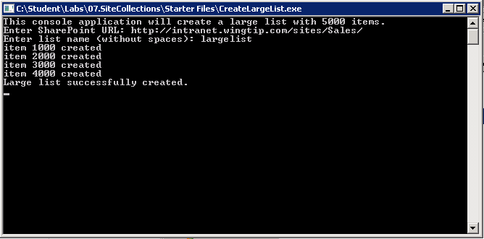

* 1. The execution takes a while because 5000 items are created in the list.

1. When the execution is finished open Internet Explorer and navigate to the **Sales** team site. The newly created list will not be visible on the Quick Launch so you have to navigate to it using the **All Site Content** hyperlink on the **Quick Launch**. There you will find the list you just created. Open the list in list view. You will not encounter performance problems because only a few items are listed.
2. Navigate to the **List Settings** page via **List Tools » List » List Settings** on the Ribbon. There you will see a message that the list threshold is 5000 and that you reached the threshold.

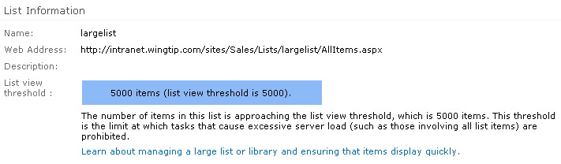

1. You are able to add more items but the List View will not render them.
2. List throttling and threshold settings can be managed from within the SharePoint Central Administration.
3. Open **SharePoint Central Administration**.
4. Choose **Application Management**.
5. Choose **Manage web applications**.
6. Select the **Wingtip Intranet** web application and click the **General Settings** button.
7. Choose the **Resource Throttling** option.

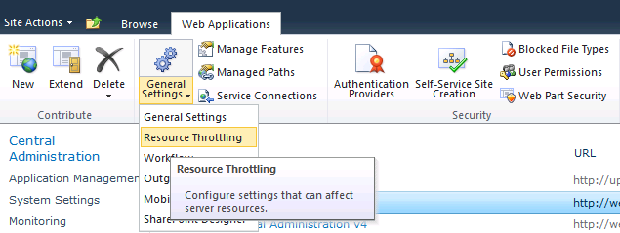

* 1. This brings you to a page where you can configure different settings concerning resource throttling:
     1. **List View Threshold**: specifies the maximum number of items that a database operation can involve at one time. Operations that exceed this limit are prohibited. The default is 5000.
     2. **Object Model Override**: if you choose to allow object model override, developers can override the List View Threshold programmatically for specific queries. The default is Yes.
     3. **List View Threshold for Auditors and Administrators**: specify the maximum number of items that an object model database query can involve at one time for users to whom you grant sufficient permissions through Security Policy. The default is 20,000.
     4. **List View Lookup Threshold**: specify the maximum number of Lookup, Person\Group, or workflow status fields that a database query can involve at one time. The default is 8.
     5. **Daily Time Window for Large Queries**: specify a daily time frame window when large queries can be executed. This time frame is preferable outside the working hours because large queries may cause excessive server load.
     6. **List Unique Permissions Threshold**: specify the maximum number of unique permissions that a list can have at one time. The default is 50,000.
     7. **Backward-Compatible Event Handlers**: turn on or off backward-compatible event handlers for this web application. They are turned off by default.
     8. **HTTP Request Monitoring and Throttling**: turn on or off the HTTP request throttling job. This job monitors front-end web server performance. The default is on.
     9. **Change Log**: specify how long entries are kept in the change logs. The default is 60 days.
  2. Set the **List View Threshold** to 8,000 and save your changes.
  3. Return to the **List Settings** of the large list to see the change in the threshold warning.

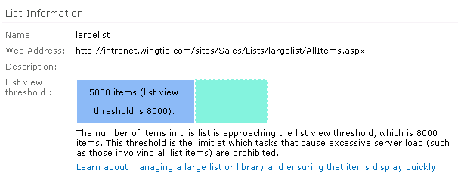

In this exercise you learned about list throttling for large lists and how to configure these thresholds.

### Exercise 8: Using SharePoint Designer 2010

SharePoint Designer 2010 is a free tool that can be used to work on SharePoint 2010 sites. For those who worked with SharePoint Designer 2007, the tool is completely revamped. It incorporated the ribbon, a navigation pane focusing on SharePoint artifacts, a breadcrumb with helpful navigation, and the concept of Gallery Pages, Settings Pages, and Editors. In this exercise you will learn how to work with SharePoint Designer 2010.

1. On the **WingtipServer** VM open **SharePoint Designer 2010**, which you can find in **Start** **» All Programs »** **SharePoint** **»** **SharePoint Designer 2010**.
2. Notice the opening screen of **SharePoint Designer 2010**. You can open an existing site, but you can also create new sites based on a number of site templates.

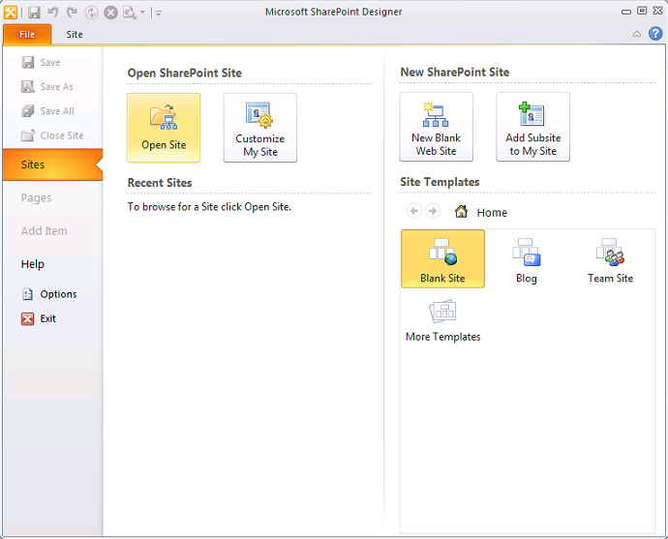

1. Click the **Open Site** button and fill out the URL http://intranet.wingtip.com/sites/sales.
2. **SharePoint** **Designer 2010** opens the site with a **Site Settings** page showing key site information and offers a wide range of possibilities going from links to quick customizations, general settings, site permissions, and sub sites. The ribbon has commands to create artifacts and manage the site as a whole.

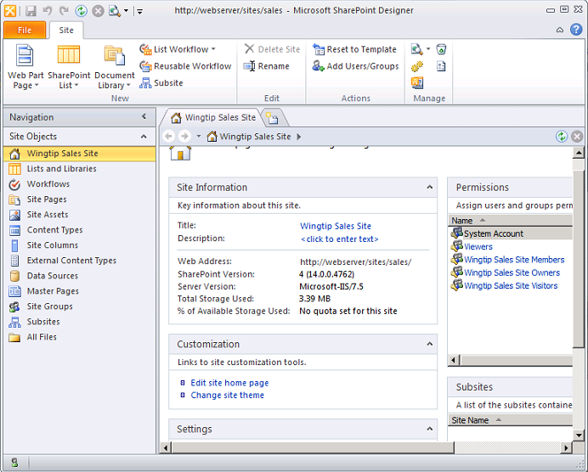

1. Take a look at the **Site Information** section.
2. Click the **Wingtip Sales Site** hyperlink next to Title. A text box appears to make it easy on you to change the title of the site.
3. From here you can choose to make changes to the home page.
4. Click the **Edit site home page** hyperlink in the **Customization** section to make some changes to the home page.

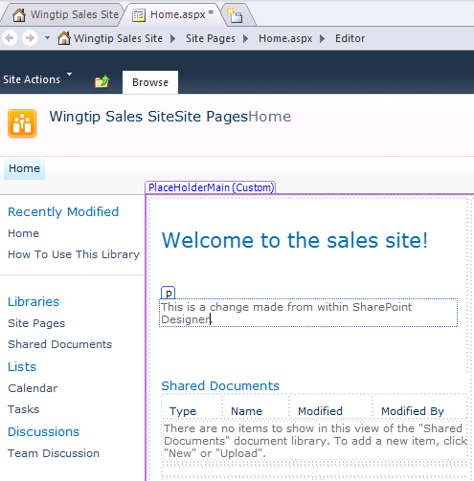

* 1. Click on the **Save** button to save your changes. You might see a dialog stating that content embedded in a form may be changed by the server. Click **Yes** to reload the page.
  2. Open the site in Internet Explorer and verify that the changes are applied
  3. Go back to the **Site Settings** page by clicking the **Wingtip Sales Site** tab.
  4. Click the **Lists and Libraries** hyperlink in the Site Objects pane to open the **List and Libraries Gallery** containing all the available templates.

1. With **SharePoint Designer 2010** it is easy to detect which style is applied where on the page by using the **Skewer Click** button, located in the **Editing** group of the ribbon on the **Home** tab.
2. Click the **Master Pages** gallery in the Site Objects pane.
3. Open the v4.master.
4. This brings you to a page where you can view and manage settings for the master page. Click the **Edit file** hyperlink in the Customizations section.
5. Click the **Skewer Click** button in the **Editing** group.

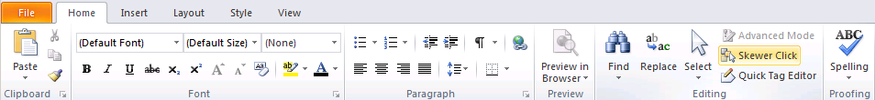

* 1. Hover over any part of the master page, click once and look at the styles that appear.

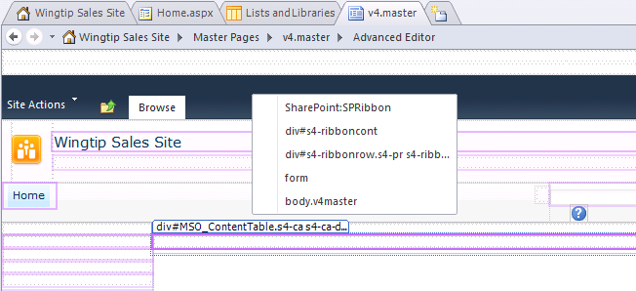

* 1. Once the page is "skewered", you get a pop up list of all the tag layers at that point. Hovering over the different tags with the CSS Properties task pane open shows you what properties are applied in each tag. Click the **View** tab, and choose **CSS Properties** from the **Task Panes** list.

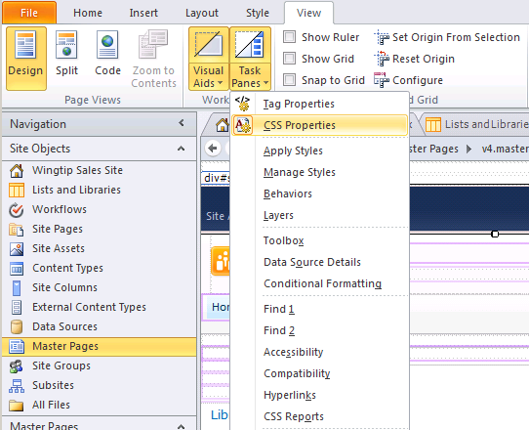

* 1. Return to the Home tab. again, click the **Skewer Click** button in the **Editing** group and then click the dark blue header.

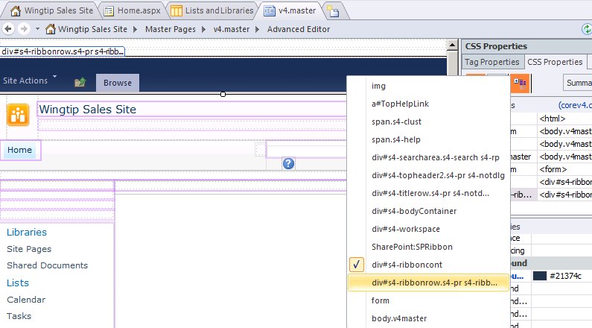

* 1. A list of styles appears in a popup. Hover over the different styles listed and see how the CSS properties change. When you come to the div#s4-ribbonrow.s4-pr style you will see that header is made up of a solid color with a transparent gradient rendered on top.

1. Return to the **Site Settings** page. From within this page you can also manage permissions.
2. Click the **Wingtip Sales Site Members**. A dialog will open, telling you which permissions are assigned at this group.
3. **Close** the dialog.
4. Take a closer look at the different possibilities. Using the left button in the Permissions ribbon allows you to add new groups and users.

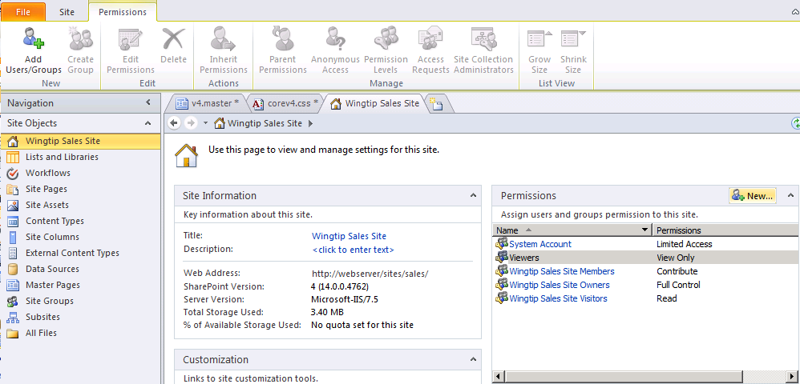

* 1. Click the **New** button in the **Permissions** section.
  2. Add Teds account as a new user and choose to add it to the **Wingtip Sales Site Members** group.

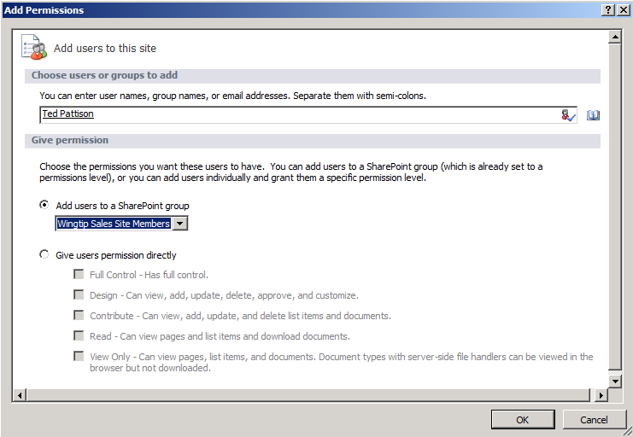

* 1. Click the **OK** button. You will get a message box specifying that the user has been added successfully to the group. Click **Yes** to view the membership of this group.
  2. This brings you to the **Site Groups** page from where you can manage the different site groups, their properties, permissions and users. The page even comes with a special **Group** ribbon.

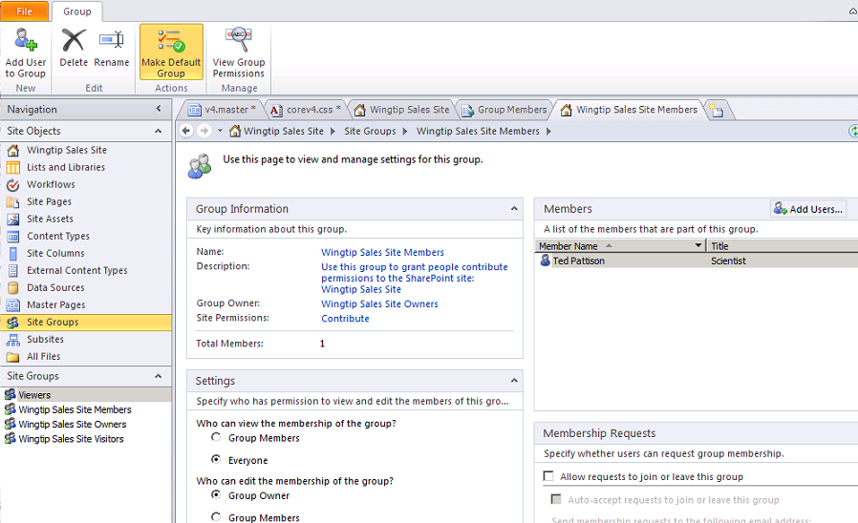

* 1. Return to the **Site Settings** page using the breadcrumb.



### Exercise 9: Limiting the use of SharePoint Designer 2010

SharePoint Designer 2010 is a tool that easily can be used by power users to perform quick customizations to a SharePoint site. Although it seems attractive to allow these customizations done by a power user, it can also be very dangerous because an inexperienced SharePoint Designer user can bring down a whole site with a careless edit.

1. In a first step we are going to make a change to the master page to bring the whole sales site down.
2. Open SharePoint Designer 2010, which you can find in **Start » SharePoint » SharePoint Designer 2010**.
   1. Open the **Sales** team site at http://intranet.wingtip.com/sites/sales.
   2. Select the **Master Pages** gallery on the Site Objects pane.
   3. Right-mouse click the v4.master master page and select **Edit File in Advance Mode** to open it in edit mode.
   4. Click the **Code View** button at the bottom of the page.

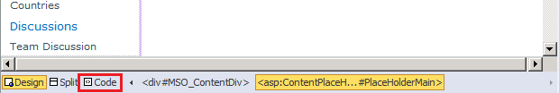

* 1. Locate the ScriptManager control on line 38 and remove it from the master page by selecting the whole line and removing it.
  2. Save your changes. If you are prompted by a dialog stating changes made to the page will no longer be based on site definition, click **Yes**.
  3. Return to Internet Explorer and navigate to the **Sales** team site. Notice the unexpected error.
  4. Return to **SharePoint Designer**. You can restore the old version of the master page by right-clicking the v4.master in the **Master Page** gallery and choosing **Reset to Site Definition** menu item.

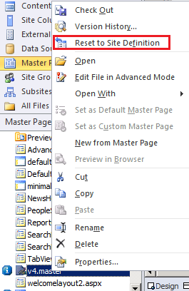

* 1. Click **Yes** when you get a message box.
  2. Return to Internet Explorer and refresh the browser. You see your home page again.
  3. **Close** SharePoint Designer.

1. You can restrict access the SharePoint Designer at site collection level.
2. In Internet Explorer, navigate to the **Site Settings** page of the Sales team site.

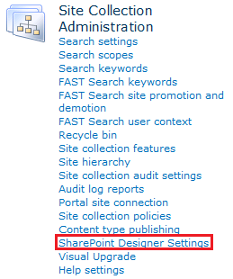

* 1. Click the **SharePoint Designer Settings** hyperlink you find under the Site Collection Administration section.
  2. You are presented with a page where you can define different levels of restrictions.
     1. The option **Enable SharePoint Designer** is enabled by default. You can choose to completely disable the use of it. Remember that is only applicable on this site collection. Uncheck this option.
     2. You can also restrict the tasks that can be performed by certain users.

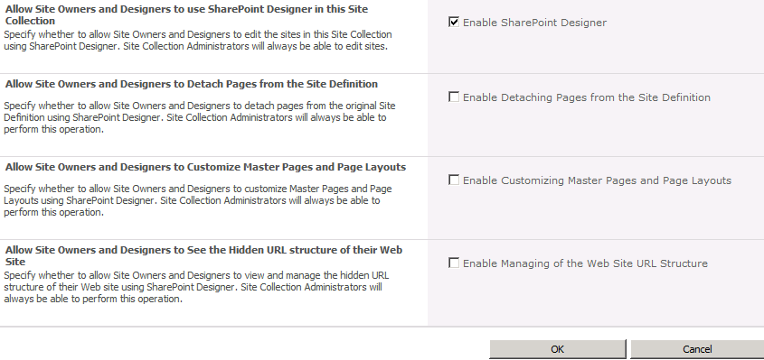

* + 1. Click the **OK** button to save your changes.
  1. As **Administrator** you still have the right to make changes in **SharePoint Designer**. You should completely log off and log on again with different credentials.

1. You can also define the same restrictions at web application level.
2. Open **SharePoint Central Administration**.
   1. Navigate to **General Application Settings**.
   2. Click the **Configure SharePoint Designer** **settings** hyperlink under the **SharePoint Designer** section.

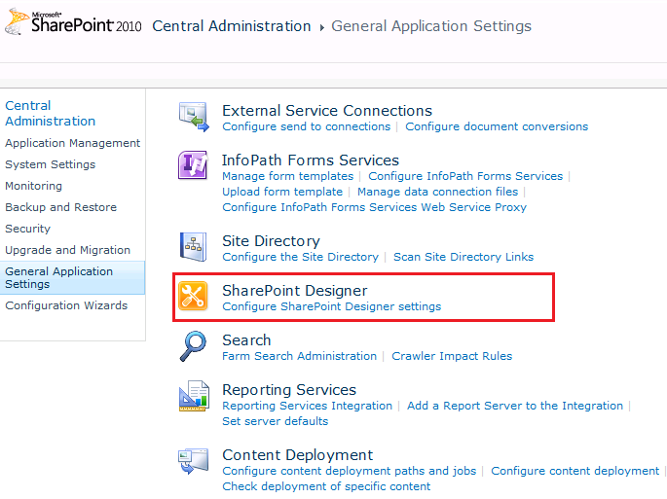

* 1. You will see a page where you can disable the use of **SharePoint Designer** at **Web Application** level, or configure limited use.